Week 2 Internship Assignment
SQL Basics

Objective: Analyze sales data using SQL with filtering, aggregation, and business queries.

- Load dataset into a SQL Database: This creates the table structure that mirrors the dataset columns.

Query :
CREATE TABLE db (
row_id INTEGER,
order_id VARCHAR(50),
order_date VARCHAR(20),
ship_date VARCHAR(20),
ship_mode VARCHAR(50),
customer_id VARCHAR(50),
customer_name VARCHAR(100),
segment VARCHAR(50),
country VARCHAR(50),
city VARCHAR(100),
state VARCHAR(100),
postal_code VARCHAR(20),
region VARCHAR(50),
product_id VARCHAR(50),
category VARCHAR(50),
sub_category VARCHAR(50),
product_name VARCHAR(500),
sales NUMERIC(12,4),
quantity INTEGER,
discount NUMERIC(5,4),
profit NUMERIC(12,4)
);

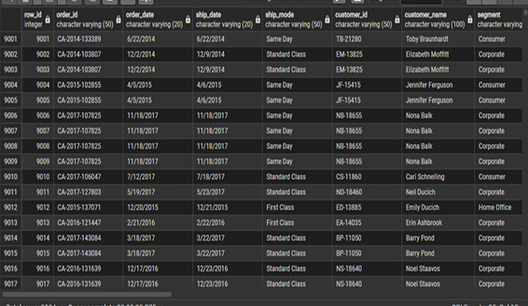

- Explore table (schema, sample data): In this step, we'll review the table by checking the total number of rows, viewing a few sample records (e.g., LIMIT 10), and examining the table structure/schema.

A: Total Row Count : This query confirms how many records were successfully imported into the database.
Query :
SELECT COUNT(*) AS total_rows
FROM db;

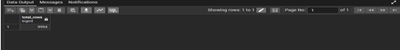

B: Sample Data (LIMIT 10) : This query displays the first 10 records for quick data inspection.

Query :
SELECT *
FROM db
LIMIT 10;

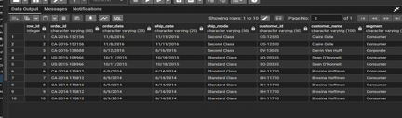

C: Schema / Structure- This query shows column names and its data types.

Query:
SELECT COLUMN_NAME, DATA_TYPE
FROM INFORMATION_SCHEMA.COLUMNS
WHERE TABLE_NAME = 'db'
AND TABLE_SCHEMA = DATABASE();

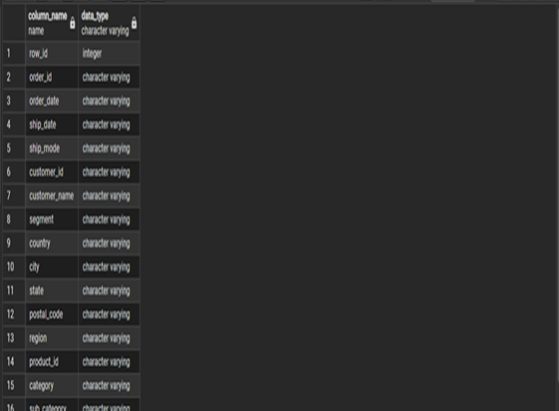

- Apply WHERE filters (region, category, date, sales): The WHERE clause was used to isolate specific slices of data based on region, category, sales threshold, and date range.

A: Filter by region(West) - Pulls only the rows where the region is 'West'.

Query:
SELECT *
FROM db
WHERE region = 'West';

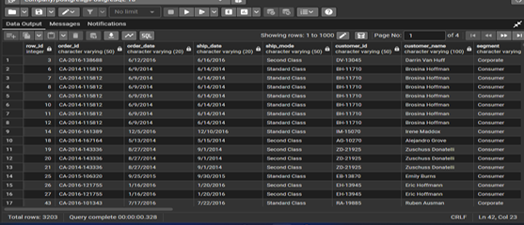

B: FILTER BY CATEGORY (Furniture) - Narrows down to Furniture products only.

Query:
SELECT *
FROM db
WHERE category = 'Furniture';

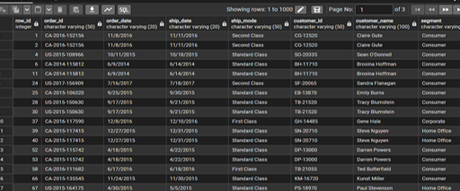

C: Filter by Sales (>500) – Filters transactions with sales >500.

Query:
SELECT *
FROM db
WHERE sales > 500;

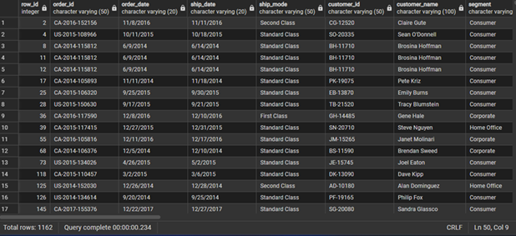

D: Filter by Date(Year 2017) – Extracts all orders placed during the year 2017.

Query:
SELECT *
FROM db
WHERE TO_DATE(order_date, '%m/%d/%Y')
BETWEEN '2017-01-01' AND '2017-12-31';

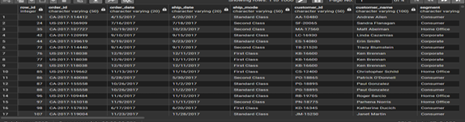

- Use GROUP BY for aggregations (sales, quantity, averages): Aggregation queries using GROUP BY were used to summarize sales and quantity data across regions and categories.

A: Total Sales by REGION – Adds up all sales for each region and sorts highest first.

Query:
SELECT region,
ROUND(SUM(sales), 2) AS total_sales
FROM db
GROUP BY region
ORDER BY total_sales DESC;
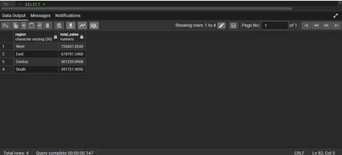

B: Total Quantity by Category – Shows the total quantity of products sold in each category.

Query:
SELECT category,
SUM(quantity) AS total_quantity
FROM db
GROUP BY category;

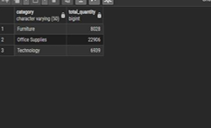

C: Average Sales by Category – Computes the average sales value for each category.

Query:
SELECT category,
ROUND(AVG(sales), 2) AS avg_sales
FROM db
GROUP BY category;

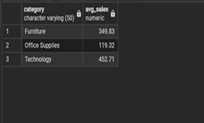

- Sort and limit results (top products, top categories): Sorting and limiting results helped identify top performers, both products and categories.

A: Top 10 Product by Sales – Finds the 10 highest earning products by total revenue.

Query:
SELECT product_name,
ROUND(SUM(sales), 2) AS total_sales
FROM db
GROUP BY product_name
ORDER BY total_sales DESC
LIMIT 10;

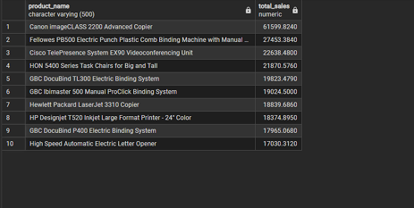

B: Top Categories by Profit – Ranks all three categories by how much profit they generated.

Query:
SELECT category,
ROUND(SUM(profit), 2) AS total_profit
FROM db
GROUP BY category
ORDER BY total_profit DESC;

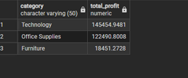

- Use cases (monthly trends, top customers, duplicates): These queries address real-world business questions, understanding trends over time, identifying key customers and spotting data issues like duplicate order IDs.

A: Monthly Trends – This shows profit change month by month, useful for spotting seasonal trends or slow periods.

Query:
SELECT DATE_FORMAT(TO_DATE(order_date, '%m/%d/%Y'), '%Y-%m') AS month,
ROUND(SUM(profit), 2) AS total_profit
FROM db
GROUP BY month
ORDER BY month;

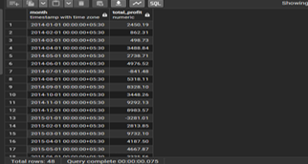

B: Top Customers – The shows customers contributing highest sales and profits.

Query:
SELECT customer_name,
COUNT(*) AS total_orders,
ROUND(SUM(sales), 2) AS total_sales,
ROUND(SUM(profit), 2) AS total_profit
FROM db
GROUP BY customer_name
ORDER BY total_sales DESC
LIMIT 10;

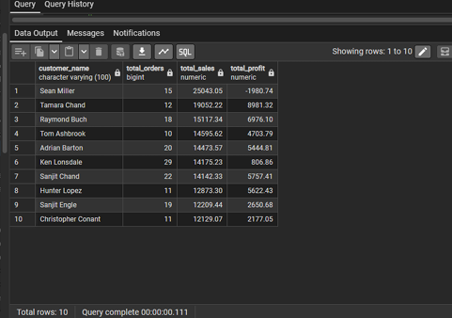

D: Duplicate order detection – Checks for order IDs appearing more than once.

Query:
SELECT order_id,
COUNT(*) AS row_count
FROM db
GROUP BY order_id
HAVING COUNT(*) > 1
ORDER BY row_count DESC;

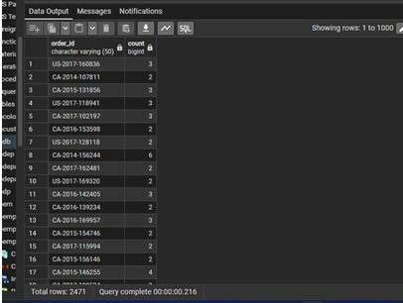
- Validate results (row counts, data quality): This looks for missing values, impossible values and confirms the total row count matches what was imported.

A: Zero Sales Check – Any transaction with 0 sales could be cancelled order or a data entry error.

Query:
SELECT *
FROM db
WHERE sales = 0;

B: Null Value Check – Checks for missing values in important columns such as order_id and customer_name.

Query:
SELECT *
FROM db
WHERE order_id IS NULL
OR customer_name IS NULL;

C: Final Row Count Validation – Run this after all imports to confirm the total number of records is still 9,994.

Query:
SELECT COUNT(*) AS total_rows
FROM db;

